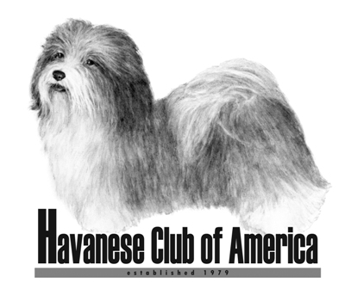

Awards Claim Form

“100 of Anything” Award

- HCA Awards are only available to members of the Havanese Club of America.
- Eligibility for club awards begins the day a person becomes a member of HCA.
- Accomplishments prior to membership will not count toward club awards.
- Only AKC titles can be used to meet the requirements.

Your Name(s): ___________________________________________________

Date of HCA Membership: _________________________________________

Name of Dog (include titles): _______________________________________

Please provide a list or an AKC report of the 100 “things” either you or your dog has accomplished. You can be as creative as you want. For example, 100 Best of Breeds for one dog, 100 reserve ribbons earned by your dogs, 100 champions sired by your dog, 100 of anything Havanese related you can think of!!

Return completed form to:

Jan Naigus
18034 Victorian Dr or email: havjrn@gmail.com
Clermont, FL 34715

Form must be received 60 Days Prior To The National Specialty Date

