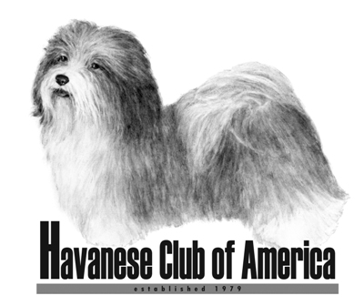

Awards Claim Form

Breeder of Merit and Breeder of Distinction

- HCA Awards are only available to members of the Havanese Club of America.
- Eligibility for club awards begins the day a person becomes a member of HCA.
- Accomplishments prior to membership will not count toward club awards.
- Only AKC titles can be used to meet the requirements.

Your Name(s): ___________________________________________________

Date of HCA Membership: _________________________________________

Award being applied for: (check one)

Breeder of Merit _____ (breeder of 10 champions)

Breeder of Distinction ______ (breeder of 25 champions)

List all of the Havanese Champions you have bred that finished since your date of HCA membership. Champions that finished prior to that date do not count toward this award, except that champions who earned a Grand Championship after your membership date will count toward the award. List the month and year each champion finished.

1________________________________________________________________

2________________________________________________________________

3________________________________________________________________

4________________________________________________________________

5________________________________________________________________

6________________________________________________________________

7________________________________________________________________

8________________________________________________________________

9________________________________________________________________

10_______________________________________________________________

If more space is needed, use the back of this form.

Return completed form to:

Jan Naigus
18034 Victorian Dr or email: havjrn@gmail.com
Clermont, FL 34715

Form must be received 60 Days Prior To The National Specialty Date

