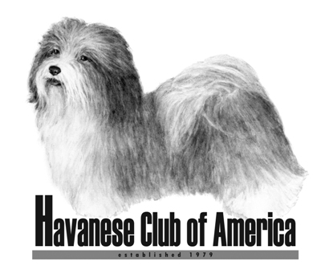

Awards Claim Form

Companion Breeder of Merit and Companion Breeder of Distinction

- HCA Awards are only available to members of the Havanese Club of America.
- Eligibility for club awards begins the day a person becomes a member of HCA.
- Accomplishments prior to membership will not count toward club awards.
- Only AKC titles can be used to meet the requirements.

Your Name(s): ___________________________________________________

Date of HCA Membership: _________________________________________

Award being applied for: (check one)

Companion Breeder of Merit _____ Breeder of 10 companion events titleholders (includes Tracking titles)

Companion Breeder of Distinction ______ Breeder of 25 companion events titleholders (includes Tracking titles)

List all of the Havanese Companion Events titleholders you have bred that finished since your date of HCA membership. Titles finished prior to that date do not count toward this award. Also list the month and year each titleholder finished. You only need to list ONE title per dog. These awards require 10 (or 25) individual dogs, not fewer dogs with multiple titles!

1________________________________________________________________

2________________________________________________________________

3________________________________________________________________

4________________________________________________________________

5________________________________________________________________

6________________________________________________________________

7________________________________________________________________

8________________________________________________________________

9________________________________________________________________

10_______________________________________________________________

If more space is needed, use the back of this form.

Return completed forms to: Jan Naigus
18034 Victorian Dr or email: havjrn@gmail.com
Clermont, FL 34715

Form must be received 60 Days Prior To The National Specialty Date

