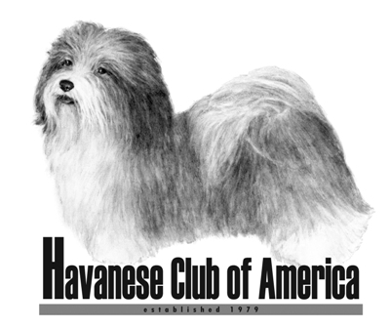

Awards Claim Form

High Scoring Obedience Dog
High Scoring Rally Dog
High Scoring Agility Dog

- HCA Awards are only available to members of the Havanese Club of America.
- Eligibility for club awards begins the day a person becomes a member of HCA.
- Accomplishments prior to membership will not count toward club awards.
- Only AKC show wins can be used to meet the requirements.

Your Name(s): ___________________________________________________

Date of HCA Membership: _________________________________________

Name of Dog (include titles): _______________________________________

Award being applied for: (check one)

High Scoring Obedience Dog _____

High Scoring Rally Dog ______

High Scoring Agility Dog ______

A minimum of 3 qualifying scores for the year is required for these awards. Scores prior to your membership date do not count toward this award. To apply for this award, please attach an AKC Individual Dog Report showing qualifying scores for 2013. Please use a separate sheet for each event if you are applying for more than one event listed above.

Return completed forms to:

Jan Naigus
18034 Victorian Dr or email: havjrn@gmail.com
Clermont, FL 34715

Form must be received 60 Days Prior To The National Specialty Date

