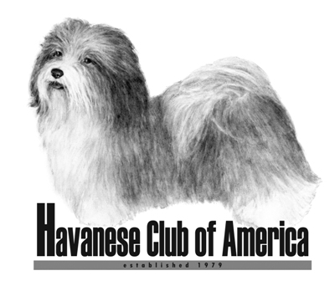

Awards Claim Form

Susan A. Nelson Versatility Award or Performance Versatility Award

Both awards may be applied for together on this form, if applicable.

- HCA Awards are only available to members of the Havanese Club of America.
- Eligibility for club awards begins the day a person becomes a member of HCA.
- Accomplishments prior to membership will not count toward club awards.
- Only AKC titles can be used to meet the requirements.

Your Name(s): ___________________________________________________

Date of HCA Membership: _________________________________________

Name of Dog (include titles): _______________________________________

Please check Award(s) being applied for:

Susan A. Nelson Versatility _____ (Conformation Championship, plus at least one title in three of the following: Agility, Obedience, Rally or Tracking)

Performance Versatility ______ (A title in three of the following: Agility, Obedience, Rally or Tracking)

Please list the titles and date earned. Only one title is needed in each category. Please be certain the date earned is after your HCA membership date.

CH or GCH Date (if applicable) ____________________________________________

Agility Title and Date_____________________________________________________

Obedience Title and Date_________________________________________________

Rally Title and Date _____________________________________________________

Tracking Title and Date __________________________________________________

Return completed form to:

Jan Naigus
18034 Victorian Dr or email: havjrn@gmail.com
Clermont, FL 34715

Forms must be received 60 Days Prior To The National Specialty Date

